**ABSTRACT**

Since we know over the past several decades, nearly all categories of fraud involving forgery have shown a consistent and disturbing year after year upward trend. We find many replicated copies of almost everything and thus it makes difficult for the consumer in deciding what is real or fake!

Hence a system is required to check the authenticity of the product. In this product we have taken a specific product say for example, cloth brand where we have come across with the problem of duplicity of brands. We can find out various duplicates of branded clothes are available in markets at reasonable rates like Zara, Puma, Nike etc. This can cause the manufacturers or the company to be in loss. So, to avoid such circumstances we have designed a system called “COUNTERFEIT DETECTION SYSTEM”.

In this we will be having a QR code associated with the unique ID of product where while scanning it will show various details about the company and the all the necessary information like whether the product is sold before or not, manufacturing place, manufacturer name, etc.

So basically, the QR is connected to the database of the company. Once the product is bought by the retailer from the company, the retailer has to feed the information about the company at the backend of the QR. Hence the consumer while buying, would scan it. If the QR is valid, it would redirect the customer to the company’s website and customer would get the required details. If the product is new or not sold before, customer would be able to write reviews. And if the product is sold before, it would generate alert and it would let the company to uphold enquiry against the seller. Hence once the product is sold it would automatically update at the backend of the company. That means, a specific product having unique product ID will be sold at once only.

In addition, failure to keep the authenticity can result in legislative, regulatory, and judicial punishment in the form of fees, penalties, civil litigation and criminal prosecution.

|  |  |
| --- | --- |
| **TABLE OF CONTENTS** | **Page No.** |
| DECLARATION………………………………………………………… | ii |
| CERTIFICATE…………………………………………………………… | iii |
| ACKNOWLEDGEMENTS…………………………………………… | iv |
| ABSTRACT…………………………………………………………… | v |
| LIST OF FIGURES……………………………………………………. | ix |
| LIST OF TABLES…………………………………………………… | xi |
| LIST OF ABBREVIATIONS…………………………………………. | xii |
|  |  |
| CHAPTER 1 INTRODUCTION                                                              .  1.1 Introduction to Project  1.2 Project Category  1.3 Objectives  1.4 Structure of The Report  CHAPTER 2 LITERATURE REVIEW  2.1       Literature Review  2.2 Research Gaps  2.3 Problem Formulation  CHAPTER 3 PROPOSED SYSTEM  3.1 Proposed System  3.2 Unique Features of The System  CHAPTER 4 REQUIREMENT ANALYSIS & SYSTEM SPECIFICATION  4.1 Feasibility Study (Technical, Economical, Operational)  4.2 Software Requirement Specification  4.3 SDLC Model  4.4    System Design  4.4.1    Data Flow Diagrams  4.4.2    Use Case Diagrams  4.5 ER Diagram    CHAPTER 5   IMPLEMENTATION  5.1 Introduction to Languages, Tools, and Technologies  CHAPTER 6 TESTING, AND MAINTENANCE  6.1 Testing Techniques and Test Cases Used  CHAPTER 7 RESULTS AND DISCUSSIONS  7.1 User Interface Representation  7.2 Description of Various Modules of The System & Snapshots  7.3 Key Findings of the Project  7.4 Back Ends Representation  CHAPTER 8 CONCLUSION AND FUTURE SCOPE  REFERENCES  Acceptance of Research Paper | .  1  1  2  2  3  5  6  7  9  10  11  12  13  13  14  15  16  17  21  26  27  28  30  31  32 |
|  |  |
|  |  |

# LIST OF FIGURES

**Figure No. Description Page No.**

2.1 Fake Goods market in Delhi, India 7

3.1 Sample QR Code used in App 8

3.2 Flowchart of Software 9

4.1 Level 0 DFD 14

4.2 Level 1 DFD 14

4.3 Use Case Diagram 15

4.4 ER Diagram 16

7.1 Login Page at Company End 22

7.2 Super Admin Panel 22

7.3.1 Product Controller Panel 1 : Add Product 23

7.3.2 Product Controller Panel 2 : Add Apparel 23

7.4.1 Manager Panel 1 : Add Employee 23

7.4.2 Manager Panel 2 : Add Retailer 24

7.5.1 Feedback Admin Panel 1: Report Section (All Tickets) 24

7.5.2 Feedback Admin Panel 1: Report Section (Ticket Opened) 24

7.5.3 Feedback Admin Panel 2: Feedback Section 25

7.4 Delivery Agent Dashboard 25

7.5 Error Page 25

7.6 Admin Error Page 26

7.7 Landing Page after QR Code is redirected 26

7.8 Report Form 26

7.9 Scanning the QR 27

7.10 Redirected Page after QR is scanned 27

7.11 Report Page 28

8.1 Submission Status 33

## LIST OF TABLES

**Table. No. Description Page No.**

6.1 Test Cases 19

6.2 Decision Table for User Login 21

6.3 Decision Table for QR Validation 21

7.1 Admin Table 29

7.2 Brand Product Retailer Table 29

7.3 Product Details Table 30

7.4 Retailer Table 30

7.5 Feedback Table 30

7.6 Report Table 30

# LIST OF ABBREVIATIONS

TrueCheck Software Project Built

QR Code Quick Response Code

UI User Interface

UX User Experience

HTML Hyper Text Markup Language

CSS Cascade Style Sheets

Flask Python Backend Framework used

AWS Amazon Web Services

DFD Data Flow Diagram

ER Diagram Entity Relationship Diagram

MySQL SQL Platform used

API Application Programming Interface

SDLC Software Development Life Cycle

## CHAPTER 1

## INTRODUCTION

### 1.1 INTRODUCTION TO PROJECT

Counterfeit Detection System is a web application that checks the authenticity of clothing products. Suppose a scenario where you want to buy a product, but you do not know that the product you are buying is original and not fake. In this situation, there is a possibility that you are getting the fake product in the name of a renowned brand by paying the amount of the original one. This fraud can lead to a loss for both the customer and the company. For the company, it steals sales by undercutting prices, damaging an authentic brand’s reputation, Harming the long-term trust built with business partners, and Forcing brands to spend time and money fighting fakes. And hence here comes the website to help users to face this kind of problem.

This website uses the concept of a QR code scan to fetch the details of the product at the time of purchase. The details include the authenticity approved by the brand, the original price, sold status of the product, and the supply chain. At the time of purchase, the user can scan the QR code of the product. If the QR code is valid then redirected to the company’s website where the product details are shown. If the Product is new, then the customer can buy it. If the QR code is invalid or the product is resold it will generate an alert to the user as well as the company. The main aim of this website is to make shopping counterfeit-free.

### 1.2 PROJECT CATEGORY

The project is a web application using several technologies such as Machine learning, Front-End and Back-End web development and database. Machine learning refers to the subset of Artificial Intelligence where programs are created without the use of human coders manually creating the program. The web frameworks use to design this project is React (Front-end) and Django (Back-end).

### 1.3 OBJECTIVES

The main objectives of the counterfeit detection system are-

* To determine whether the product is authentic or fake.
* To determine the sold status of the product so that it cannot be resold.
* To reduce the loss of the company by counterfeiting clothing products.
* To uphold the authentic brand’s reputation.
* To ensure the government get the tax percentage by the transaction of purchase of clothing products.

### 1.4 STRUCTURE OF THE REPORT

This report is structured to provide a comprehensive overview of the Counterfeit Detection System, its development process, and its potential impact on addressing the challenges posed by counterfeit products in the market. The report is organized into the following sections:

.

* **Introduction:** This section introduces the Counterfeit Detection System, outlining its objectives, significance, and the problem it aims to address.
* **Literature Review:** The literature review section presents a review of existing literature related to QR code technology, counterfeit brands, consumer attitudes, and initiatives to combat counterfeiting.
* **Proposed System:** This section describes the proposed Counterfeit Detection System in detail, including its architecture, functionality, and unique features. It explains how the system leverages QR code technology to authenticate products and empower consumers to make informed purchasing decisions.
* **Requirement Analysis and System Specification:** The requirement analysis and system specification section outline the technical, functional, and performance requirements of the Counterfeit Detection System.
* **Implementation:** The implementation section provides an overview of the technologies, tools, and languages used to develop the Counterfeit Detection System. It describes the development process and highlights key components and functionalities of the system.
* **Testing and Maintenance:** This section discusses the testing techniques, test cases, and maintenance strategies employed to ensure the reliability, performance, and security of the Counterfeit Detection System.
* **Conclusion and Future Scope:** The conclusion and future scope section summarizes the findings of the report and discusses the implications of the Counterfeit Detection System.
* **References:** The references section provides a list of all the sources cited in the report, including research papers, articles, and other relevant literature.

## CHAPTER 2

## LITERTAURE REVIEW

### 2.1 LITERATURE REVIEW

* **An Introduction to QR Code Technology** [1]

QR (Quick Response) codes are 2D matrix codes that are designed to store and quickly decode large amounts of data using handheld devices like smartphones. They consist of black modules arranged in a square pattern on a white background. Compared to traditional 1D barcodes, QR codes offer higher data storage capacity, faster readability, and various advantages such as error-correction capabilities and different versions.

The paper highlights that QR codes have gained popularity in diverse fields such as marketing, security, and academics. They are widely used for applications related to tracking, labelling products, and providing quick access to information. The increasing number of smartphone users has contributed to the widespread adoption of QR codes.

The information capacity of a QR code varies depending on the version and the type of data encoded. Different versions of QR codes exist, ranging from Version 1 to Version 40, with each version having a different module configuration. The higher the version, the more modules are required, resulting in larger QR code symbols.

QR codes employ error correction techniques to ensure accurate decoding even if the code is damaged or dirty. Reed-Solomon codes, a widely used mathematical error-correction method, are used to generate error correction codewords. The paper mentions that four levels of error correction are available, with higher levels providing better recovery capabilities.

The structure of a QR code consists of square modules arranged in a regular square array. It includes function patterns such as finder patterns, separators, timing patterns, and alignment patterns. These patterns help QR code scanners correctly identify and orient the code for decoding. The encoding region of a QR code contains data representing version information, format information, and error correction codewords.

Overall, the paper provides an introduction to QR code technology, discussing its features, applications, information capacity, error correction, and structure. It emphasizes the growing popularity of QR codes and their acceptance worldwide.

* **A study on counterfeit brands, consumer attitude and initiatives to stop counterfeiting in India** [2]

The study on counterfeit brands, consumer attitude, and initiatives to stop counterfeiting in India addresses the global problem of counterfeiting, which has negative implications for industries and the economy. Counterfeit brands are unauthorized copies or imitations of genuine brands, created with the intention of exploiting the reputation and popularity of the authentic brands. This not only affects the growth and profitability of legitimate businesses but also poses risks to consumers, as counterfeit products are often of inferior quality and can be harmful.

The research highlights that counterfeiting is a thriving market globally, with estimates suggesting that the economic value of counterfeited and pirated products could reach a staggering $2.3 trillion by 2022. Counterfeit brands in various industries, including luxury goods, electronics, pharmaceuticals, and packaged foods, have a significant presence in both Indian and international markets.

One of the key factors contributing to the growth of counterfeiting is the positive attitude of consumers towards counterfeit brands. Some consumers are attracted to counterfeit products due to their lower prices or the perception of owning a luxury brand at a fraction of the cost. Inadequate legal frameworks and enforcement mechanisms also contribute to the proliferation of counterfeit products.

The study emphasizes the need for effective strategies and a strong legal framework to combat counterfeiting. It examines the initiatives taken in India to educate consumers about the risks and consequences of purchasing counterfeit products. Additionally, it explores the cases filed against fake brands, shedding light on the legal challenges and actions taken by legitimate brand owners to protect their intellectual property rights.

Understanding the market share captured by counterfeit products in different industrial sectors in India is a crucial aspect of the study. It helps identify the extent of the problem and provides insights for manufacturers and retailers of genuine brands to develop robust marketing strategies to tackle counterfeiting effectively.

Overall, the research aims to contribute to the understanding of counterfeiting practices in India, promote consumer awareness, and assist in the formulation of comprehensive measures to combat counterfeiting and protect the interests of legitimate businesses and consumers.

* **Counterfeit detection with QR Codes** [3]

Counterfeit detection with QR Codes is a conference paper that discusses the use of QR Codes as a potential solution to combat industrial counterfeiting. The authors highlight the advantages of QR Codes over traditional security measures, such as taggants, holograms, and security inks, due to their ease of integration into existing production workflows, simplicity of verification, and cost-effectiveness at scale. QR Codes also have the added benefit of conveying a product's digital identity and history, facilitating brand-consumer connections.

However, the paper emphasizes that QR Codes alone do not provide sufficient protection against cloning or copying. To address this limitation, the authors propose the integration of copy detection patterns (CDPs) into QR Codes. CDPs, also known as secure graphics or graphical codes, are copy-sensitive layers that can be scanned and analysed using a smartphone app. By inserting a CDP into the digital image of the QR Code before printing, the system can differentiate between original products and counterfeits.

The paper discusses the challenges of implementing counterfeit detection measures in real-world production environments, where QR Codes are printed at mass scale and scanned by consumers using their smartphones. It notes that most existing techniques for securing QR Codes have not been tested in such environments. To overcome these challenges, the authors present a system that incorporates CDPs into QR Codes and has been successfully deployed in the market for several years.

The authors also provide a brief review of existing solutions for securing QR Codes against counterfeiting, including methods that embed random textures throughout the QR Code or replace specific texture patterns in the black cells of QR Codes.

Overall, the paper highlights the potential of integrating copy detection patterns into QR Codes to enhance their effectiveness as a counterfeit detection measure. This technology offers practical solutions for brand protection and counterfeit detection in various industries, providing a means to authenticate products and prevent the unwitting purchase and use of counterfeit goods.

### 2.2 RESEARCH GAPS

* **Limited Technical Insight:** While existing studies offer an overview of QR code technology and its applications, there is a dearth of in-depth analysis regarding the technical implementation of QR code-based counterfeit detection systems. Future research should focus on providing detailed insights into the technical challenges, considerations, and methodologies involved in the development and deployment of such systems.
* **Incomplete Understanding of Consumer Behaviour:** Despite discussions on consumer attitudes towards counterfeit products, there exists a gap in comprehensively understanding the underlying motivations and decision-making processes driving consumer behaviours in relation to counterfeit goods. Future research endeavours should aim to bridge this gap by conducting thorough analyses of consumer perceptions, preferences, and behaviours within the context of counterfeit product markets.
* **Industry-Specific Challenges:** While some literature addresses counterfeiting across various industries, there is a lack of industry-specific studies that delve into the unique challenges and dynamics within particular sectors. Further research is warranted to conduct focused investigations into industry-specific trends, vulnerabilities, and best practices for combating counterfeiting.
* **Insufficient Evaluation of Detection Technologies:** While the use of QR codes and other technologies for counterfeit detection is discussed, there is a notable absence of comprehensive evaluations comparing the effectiveness, efficiency, and usability of different detection methods. Future research should involve rigorous testing and comparative analyses of various detection technologies to ascertain their strengths, limitations, and applicability across diverse contexts.
* **Sparse Coverage of Policy Implications:** Despite the significance of policy interventions and regulatory frameworks in combating counterfeiting, there is limited research evaluating the effectiveness and impact of such measures. Subsequent research efforts should explore the role of policy and regulatory frameworks in deterring counterfeiting activities and protecting the interests of consumers and businesses.

### 2.3 PROBLEM FORMULATION

At the time of shopping clothing products, there is a possibility that you are getting the fake product in the name of a renowned brand by paying the amount of the original one and sometimes it becomes difficult for the customer to decide whether it is real or fake. This fraud can lead to a loss for both the customer, the company as well as the Government. For the customer, it is not giving them the authentic products. For the company, it steals sales by undercutting prices, damaging an authentic brand’s reputation, harming the long-term trust built with business partners, and Forcing brands to spend time and money fighting fakes. Counterfeiting has a direct impact on government as when counterfeited goods reach the market, there is no tax generation thus government does not get any percentage from the transaction. So, it becomes necessary to detect the authenticity of the products.

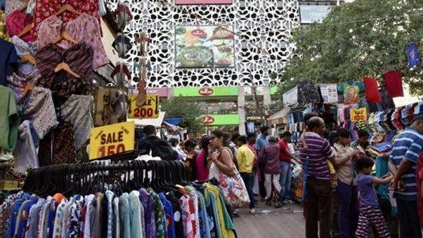

### Fig. 2.1 Fake Goods market in Delhi, India

## CHAPTER 3

## PROPOSED SYSTEM

### 3.1 PROPOSED SYSTEM

In this “COUNTERFEIT DETECTION SYSTEM”, we will be having a QR code associated with the unique ID of product where while scanning, it will show various details about the company and the all the necessary information like whether the product is sold before or not, manufacturing place, manufacturer name, etc.

Here's how the Counterfeit Detection System works:

1. **QR Code Scanning**: As consumers prepare to make a purchase, they encounter a crucial checkpoint—the QR code affixed to the product. With a quick scan using their mobile devices, they initiate the process.



Fig. 3.1 Sample QR Code used in App

1. **Validation and Product Details:** The system springs into action, rigorously validating the QR code's authenticity. If the QR code checks out as genuine, users are seamlessly redirected to the official website of the brand, where a wealth of essential product details awaits. These details include a stamp of authenticity from the brand, the original price of the product, its current sold status, and insights into its supply chain journey.

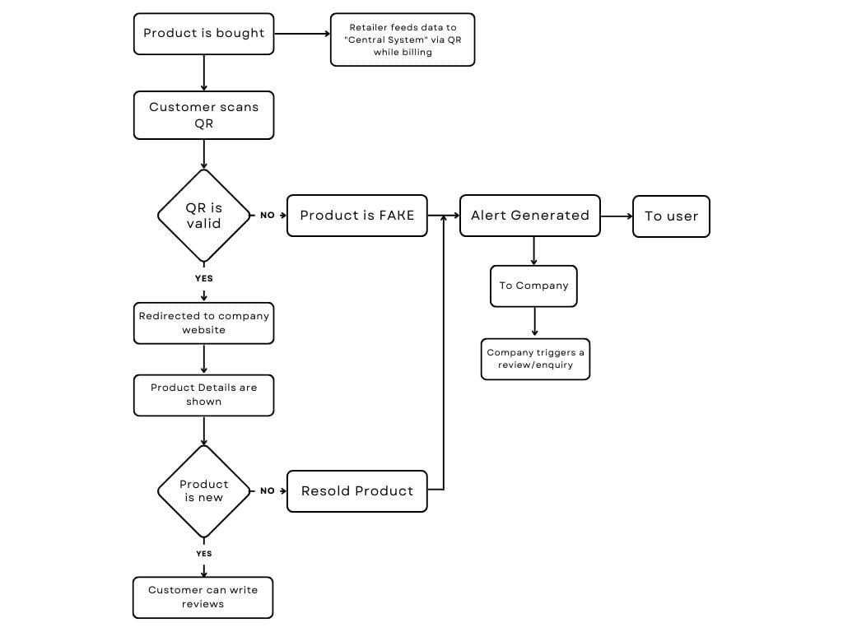

Fig. 3.2 Flowchart of Software

These details include a stamp of authenticity from the brand, the original price of the product, its current sold status, and insights into its supply chain journey.

1. **Informed Decision-Making**: Armed with this valuable information, consumers are empowered to make informed decisions about their purchase. If the product is confirmed as new and unsold, they can proceed with confidence, knowing they are acquiring an authentic item. On the other hand, if the QR code raises any doubts or the product has been resold, the system triggers an alert, both to the user and the concerned brand. This proactive approach serves as a powerful deterrent to counterfeit activity.

### 3.2 UNIQUE FATURES OF THE SYSTEM

* This system is determining whether the product is authentic or fake.
* This detection system also determines the sold status of the product so that it cannot be resold.
* This system also ensures that the government gets the tax percentage by the transaction of clothing products at the time of purchasing it.
* This system also upholds the authentic brand’s reputation.
* This system also helps in reduction of the loss of the company by counterfeiting clothing products.

## CHAPTER 4

## REQUIREMENT ANALYSIS AND SYSTEM SPCIFICATION

### 4.1 FEASIBILITY STUDY (TECHNICAL, ECONOMICAL, OPERATIONAL)

#### 4.1.1 TECHNICAL FEASBILITY

**Technology Assessment:** The required technologies for QR code generation and scanning, database management (MySQL), and web development (Flask, HTML/CSS/JS) are mature and readily available. The system's architecture should be scalable to accommodate future enhancements and integration with advanced technologies like machine learning.

**Resource Availability:** Evaluate the availability of skilled personnel and technical resources required for development. Consider outsourcing specific tasks, if necessary, expertise is lacking internally.

**Integration and Compatibility:** Ensure seamless integration of various components and compatibility across different platforms and devices. Conduct thorough testing to identify and address any integration or compatibility issues during development.

**Security Measures:** Implement robust security measures to protect user data, prevent unauthorized access, and ensure compliance with data privacy regulations (e.g., GDPR, CCPA). Regular security audits and updates should be conducted to mitigate potential risks.

#### 4.1.2 ECONOMICAL FEASBILITY

**Cost Analysis:** Conduct a comprehensive cost analysis covering development, infrastructure, licensing, and operational expenses. Calculate the projected return on investment (ROI) based on potential revenue streams, cost savings from counterfeit prevention, and enhanced brand reputation.

**Risk Assessment:** Identify potential risks and uncertainties that may impact project costs and returns. Develop contingency plans to mitigate risks and ensure financial viability.

**Market Analysis:** Evaluate market demand and competition to assess the system's revenue potential and competitive positioning. Identify target market segments and develop marketing strategies to drive adoption and revenue growth.

**Sustainability:** Assess the long-term sustainability of the system, considering factors such as maintenance costs, scalability, and ongoing operational expenses. Develop a financial sustainability plan to ensure continued profitability and growth.

#### 4.1.3 TECHNICAL FEASBILITY

**User Acceptance:** Conduct user surveys and feedback sessions to gauge user acceptance and identify potential usability issues. Incorporate user feedback into the design and development process to enhance user experience and adoption.

**Training and Support:** Develop comprehensive training programs and support materials to facilitate user onboarding and system adoption. Provide ongoing technical support and assistance to address user queries and issues effectively.

**Operational Efficiency:** Streamline business processes and workflows to maximize operational efficiency and productivity. Implement automation and workflow optimizations to minimize manual efforts and streamline operations.

**Compliance and Risk Management:** Ensure compliance with legal and regulatory requirements related to counterfeit detection, data privacy, and consumer protection. Implement risk management strategies to mitigate legal and operational risks associated with system deployment and operation.

### 4.2 SOFTWARE REQUIREMENT SPECIFICATION

#### 4.2.1 External Interface Requirements

***A. User Interfaces***

**Home page:** The home page should include a brief introduction to the app, along with a search bar that allows users to search for clothes by brand, type, or other criteria.

**Authentication:** The app should require users to authenticate themselves in order to access certain features, such as reporting suspicious activity or managing their accounts. The authentication process should be simple and secure, and may include options such as username and password, social media login, or two-factor authentication.

**Product verification:** When a user searches for a particular item of clothing, the app should display information about that product, including the brand, type, and other relevant details. The app should also provide a way for users to verify the authenticity of the product, such as by scanning a QR code or entering a serial number.

**Reporting suspicious activity:** The app should include a feature that allows users to report suspicious activity, such as the sale of counterfeit clothes or other fraudulent activity. This feature should be easily accessible from the home page and should include a form that allows users to provide details about the suspicious activity.

**Account management:** The app should allow users to manage their accounts, including updating their personal information, viewing their purchase history, and accessing support resources. The account management feature should be easy to use and should include clear instructions for each task.

**Help and support:** The app should include a help and support section that provides users with answers to common questions, troubleshooting tips, and contact information for technical support or customer service.

#### Performance Requirements

Performance is one of our major concerns. Since the core objective of this project is to efficiently manage all the queries raised for authenticity, we have to make our website fast and efficient. We shall achieve this through minimal response times when users will enter our website. Our website should be able to identify the authenticity of a product with the help of a scanner.

#### Safety Requirements

Since this is an online platform, we won’t have to deal with safety issues much often. But to avoid unnecessary risks, and potential crises, customers will be able to report the issue/problem to us for violating community standards.

#### Security Requirements

Users will be able to redirect to the website if the QR code on the product is valid. This ensures the security of the website.

**4.3 SDLC Model to Be Used**

For the development of the Counterfeit Detection System, we have adopted the Agile Software Development Life Cycle (SDLC) model. Agile methodology is chosen for its iterative and incremental approach, allowing for flexible adaptation to changing requirements and continuous improvement throughout the development process.

**4.4 SYSTEM DESIGN**

**4.4.1 DATA FLOW DIAGRAMS**

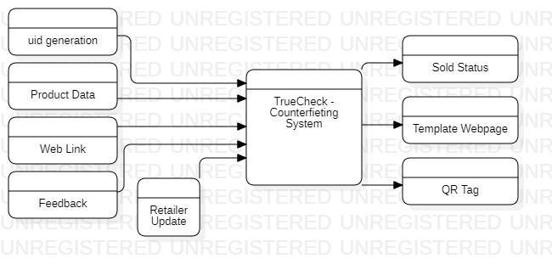

Fig. 4.1 Level 0 DFD

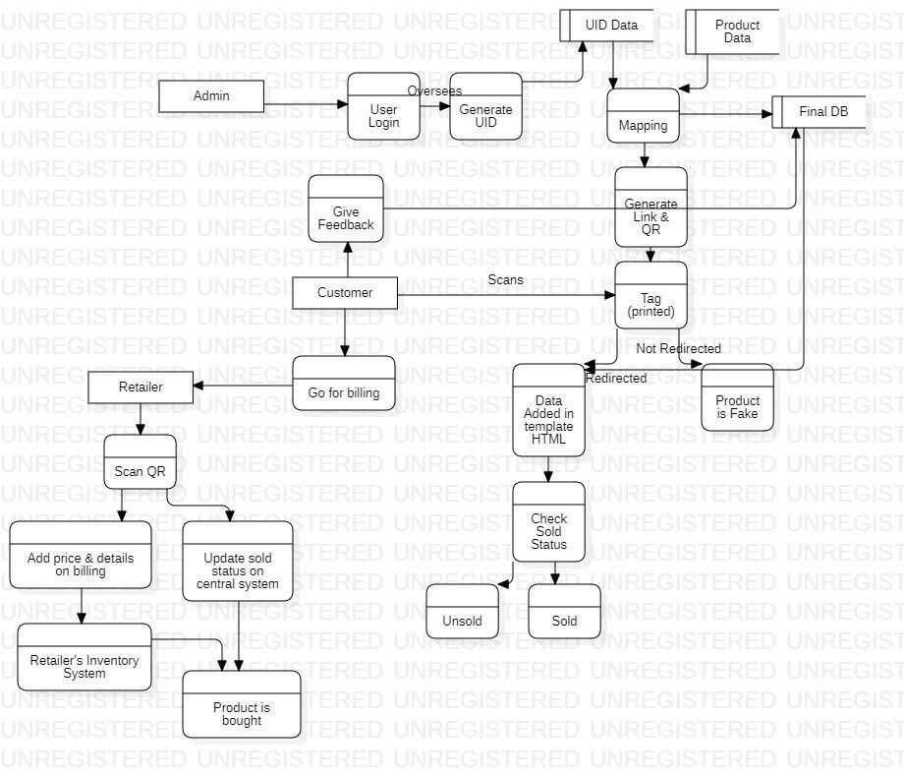

Fig. 4.2 Level 1 DFD

**4.4.2 USE CASE DIAGARAMS**

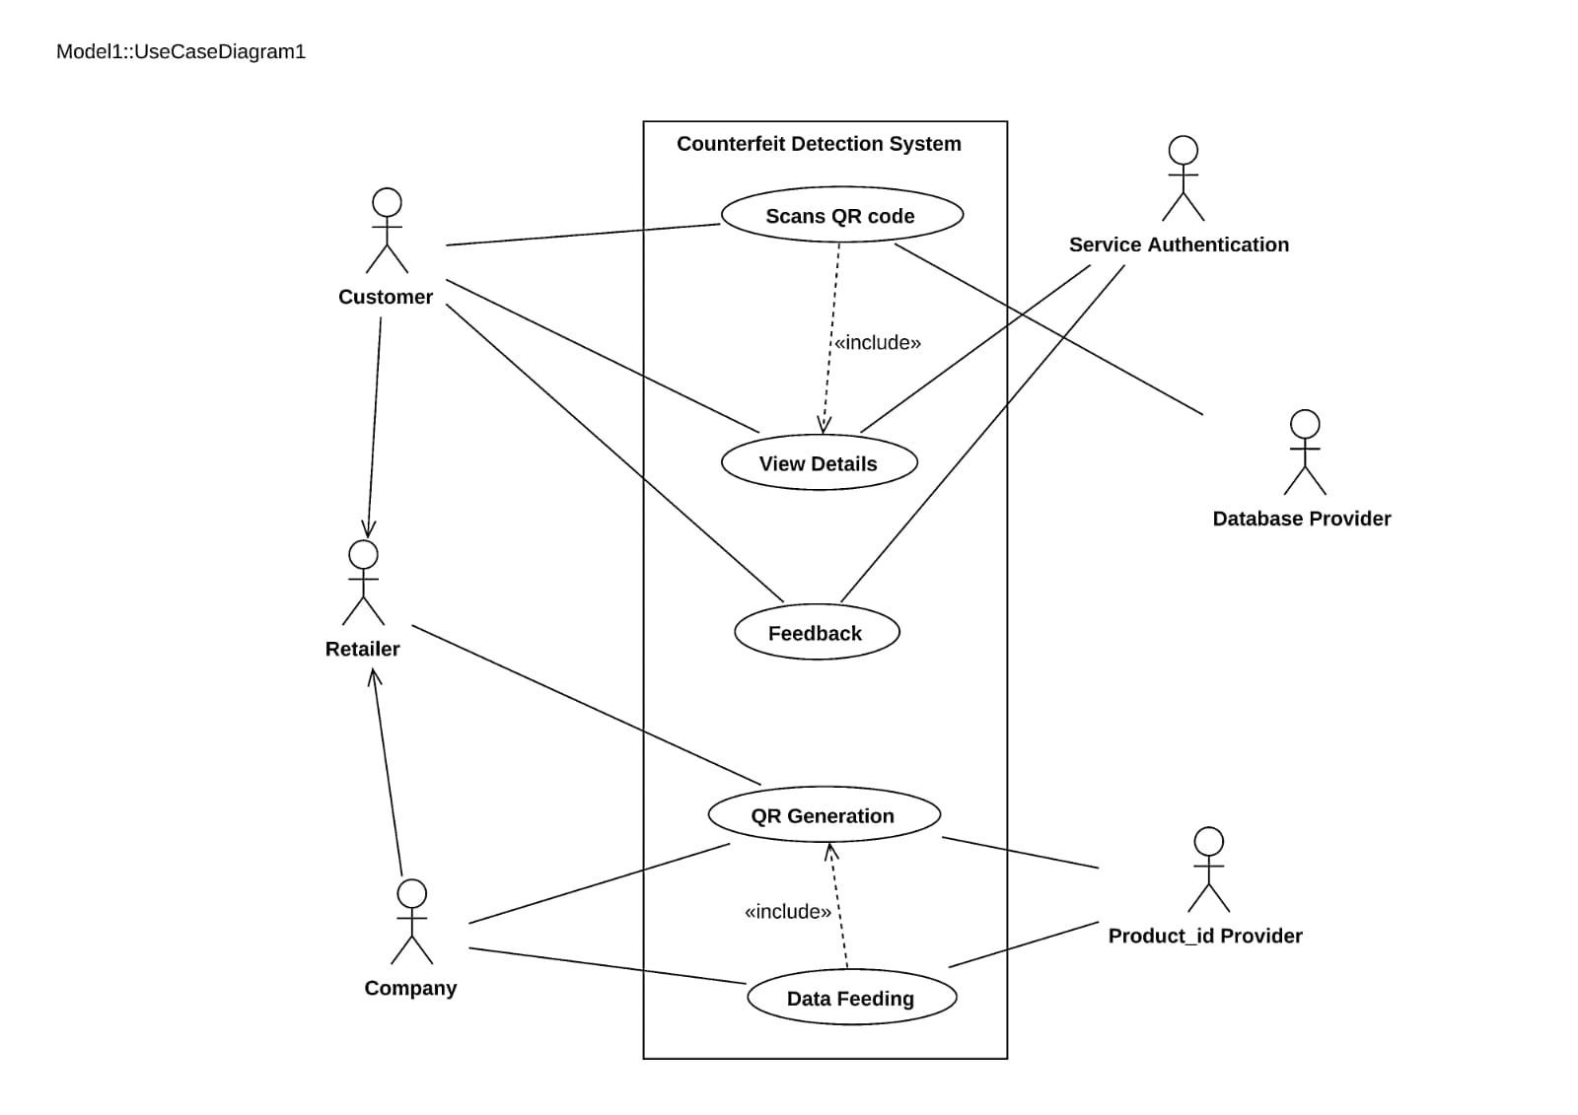

Fig. 4.3 Use Case Diagram

**4.4.2 ER DIAGARAM**

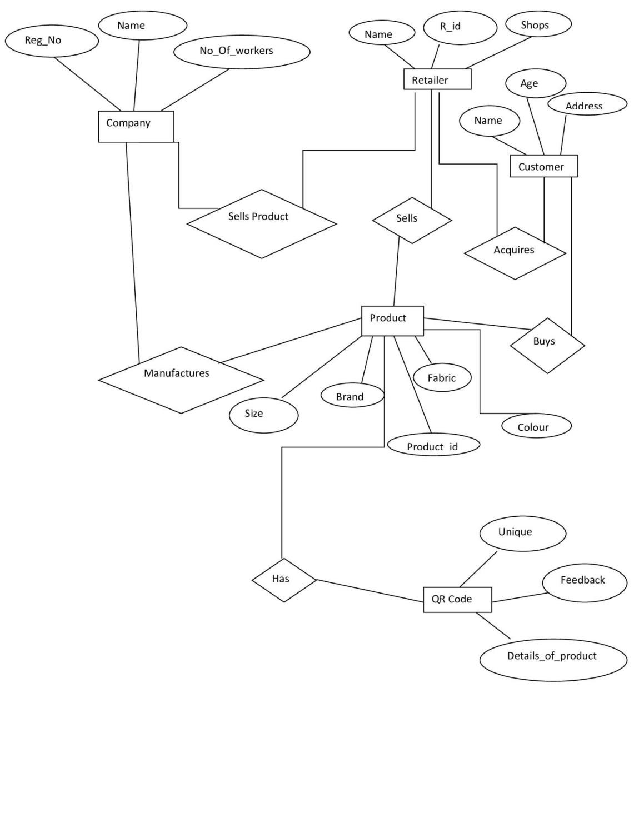

Fig. 4.4 ER Diagram

**CHAPTER 5**

**IMPLEMENTATION**

**5.1 INTRODUCTION TO LANGUAGES, TOOLS AND TECHNOLOGIES**

### 5.1.1 Implementation

Our Web app would use the following technologies on the software interface.

1. **qrcode**
   1. We will be using a python library called ‘qr code’ at the backend for the generation of qr codes.
2. **pyzbar**
   1. We will be using a python library called ‘qr code’ at the backend for the scanning of qr codes.
3. **MySQL** 
   1. Database generation and administration
4. **Mysql.connector** 
   1. Python Library for Database Connectivity
5. **UI/UX** 
   1. We will use Figma and VS Code for UI/UX generation.
6. **Web Application**
   1. **Front End:**
      1. HTML
      2. CSS
      3. JS
   2. **Back End** 
      1. Python
      2. Flask
   3. **Database** 
      1. MySQL

**CHAPTER 6**

**TESTING AND MAINTENANCE**

**6.1 TESTING TECHNIQUES AND TEST CASES USED**

The testing to be performed is white box testing. The testing is performed by the developer’s team along with QA and Configuration Manager.

**Unit Testing:**

* Scope: Individual components and modules of counterfeit detection system are being considered.
* Objective: To verify that each component works as intended, including admin side, login module, manager module, etc.
* Testing Approach: Developers and testers conduct unit tests to validate the correctness of the algorithm at a granular level.

**Integration Testing:**

* Scope: The interactions and interfaces between various components, modules, and frameworks used in the project.
* Objective: To ensure that the integration of different components does not introduce errors or inconsistencies in the QR validation process.
* Testing Approach: Developers and testers assess the data flow and interactions between components and modules and detect any integration issues.

**Functional Testing:**

* Scope: The complete counterfeit detection system.
* Objective: To validate that the system functions according to specified requirements and that it performs accurate procedure.
* Testing Approach: Testers execute functional tests by providing QR codes and verifying that the output determines which product is counterfeited or not.

**Performance Testing:**

* Scope: Assessing the system's speed and efficiency in handling multiple scanning requests at the same time.
* Objective: To measure how well the system performs in terms of processing time, memory utilization, and resource consumption.
* Testing Approach: Performance tests evaluate the system's response time and resource usage under various loads and conditions.

**Usability Testing:**

* Scope: The user interface and user experience.
* Objective: To assess how user-friendly and intuitive the interface is for users to scan the qr code, redirect to the company’s database and give details about the product.
* Testing Approach: Usability tests involve users interacting with the system to evaluate the ease of use, clarity, and navigation of the interface.

**Security Testing:**

* Scope: The system's security mechanisms, especially for handling bulky data.
* Objective: To identify and mitigate potential security vulnerabilities, including data breaches and unauthorized access of third party.
* Testing Approach: Security testing includes penetration testing, data encryption checks, and access control assessments.

**Compatibility Testing:**

* Scope: The system's compatibility with various platforms and devices.
* Objective: To ensure that the system functions correctly on different browsers, operating systems, and devices.
* Testing Approach: Testers verify that the system is compatible with a range of devices and configurations.

**Regression Testing:**

* Scope: The entire system after updates or changes.
* Objective: To confirm that new changes or enhancements do not introduce defects or negatively impact existing functionality.
* Testing Approach: Automated regression tests are executed to validate that previously tested features still work as expected.

**6.2 TEST CASES USED**

## Test cases:-

Table 6.1 Test Cases

|  |  |  |  |  |  |
| --- | --- | --- | --- | --- | --- |
| **Test Case** | **Test**  **Objective** | **Test Data** | **Expected Result** | **Actual Result** | **Pass/Fail** |
| 1 | User Login | User Id and  Password | Only Valid User login in the system | Unauthorized User cannot login | Pass |
| 2 | Uid  Generation | Mapping of uid with database | Uid should be accurately mapped  with database of company | Unique Id generated | Pass |
| 3 | QR Code  Generation | Uid associated with product generate QR | QR code should be generated | Scannable QR  Code generated | Pass |
| 4 | QR Code Scanning | Scanning of qr code is done | QR Code should be scanned properly | QR code recognizable | Pass |
| 5 | Redirection to the  company’s  site | QR Code  validation | Generated QR code should be valid | Valid QR, redirected to company’s site | Pass |
| 6 | Alert  Generation | Verification of  QR Code | If the product is counterfeited, alert is generated | Fake Product,  hence generates  alert | Pass |
| 7 | User Interface of company’s  site | Validation of Company’s  data | UI should have user friendly experience | All necessary details of the product are visible to users | Pass |
| 8 | Updation of status of product | Company’s  Database | It should  automatically update the status of product  as sold after selling to  consumer | Automatically status updated | Pass |
| 9 | Verify data security | Testing with simulated security breaches | No unauthorized access or data breaches detected | Unauthorized User cannot access | Pass |
| 10 | Assess the impact of updates | System before and after updates | Previously tested features still work as expected | Previously tested features work accurately | Pass |
| 11 | User  Feedback for the product | User  Interface of the system | User should be able to write feedback of the product to the company’s site | User drops reviews about the product | Pass |

### 6.3 DECISION TABLE FOR USER LOGIN

Table 6.2 Decision Table for User Login

|  |  |  |  |  |
| --- | --- | --- | --- | --- |
| **Conditions** | **Rule 1** | **Rule 2** | **Rule 3** | **Rule 4** |
| Username | False | True | False | True |
| Password | False | False | True | True |
| Output(e/h) | Error | Error | error | homepage |

### 6.4 DECISION TABLE FOR QR VALIDATION

Table 6.3 Decision Table for QR Validation

|  |  |  |  |  |
| --- | --- | --- | --- | --- |
| **Conditions** | **Rule 1** | **Rule 2** | **Rule 3** | **Rule 4** |
| QR valid | False | True | False | True |
| QR Invalid | False | False | True | True |
| Output | Error | Original Product | Counterfeited Product | error |

**CHAPTER 7**

**RESULTS AND DISCUSSIONS**

### 7.1 USER INTERFACE REPRESENTATION

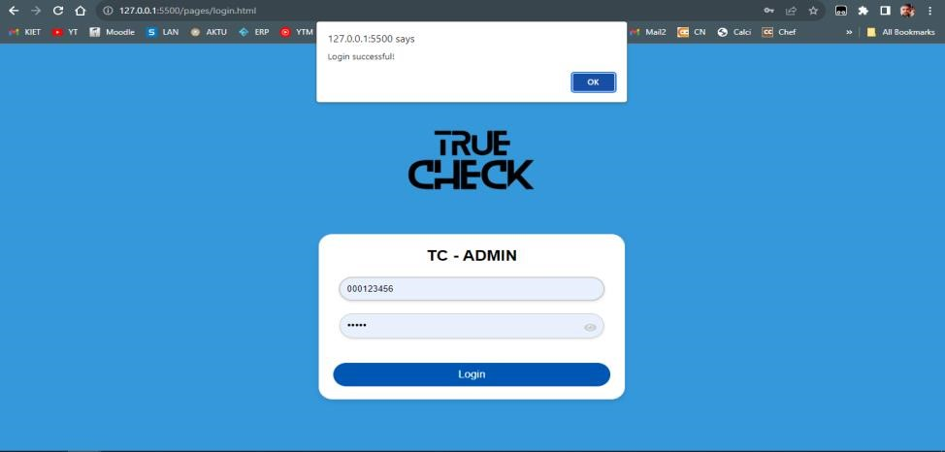

Fig. 7.1 Login Page at Company End

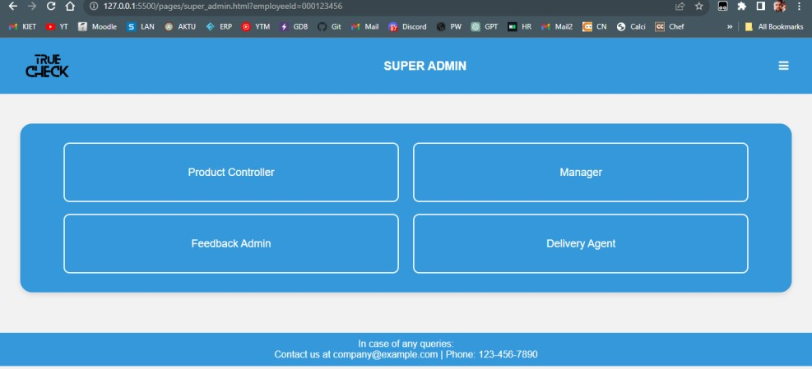

Fig. 7.2 Super Admin Panel

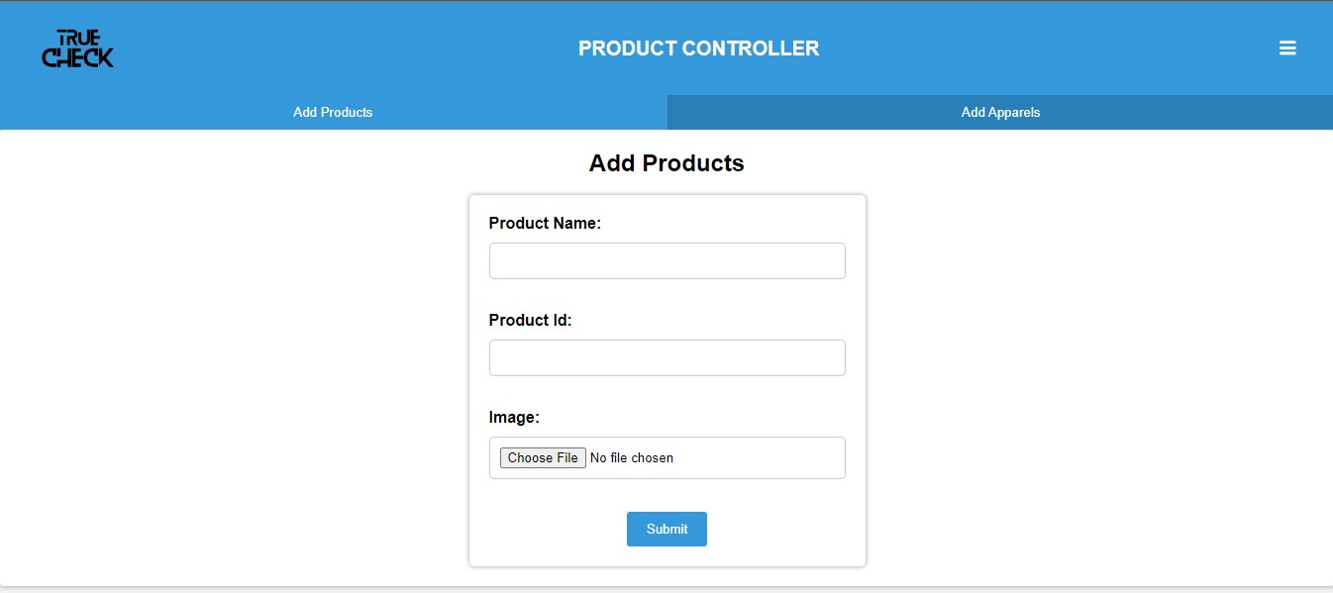

Fig. 7.3.1 Product Controller Panel 1 : Add Product

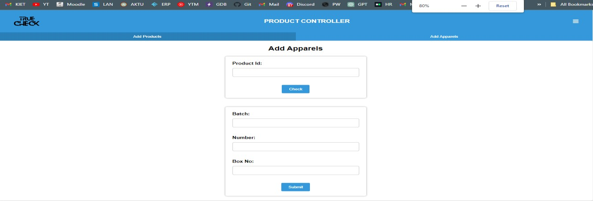

Fig. 7.3.2 Product Controller Panel 2 : Add Apparel



Fig. 7.4.1 Manager Panel 1 : Add Employee

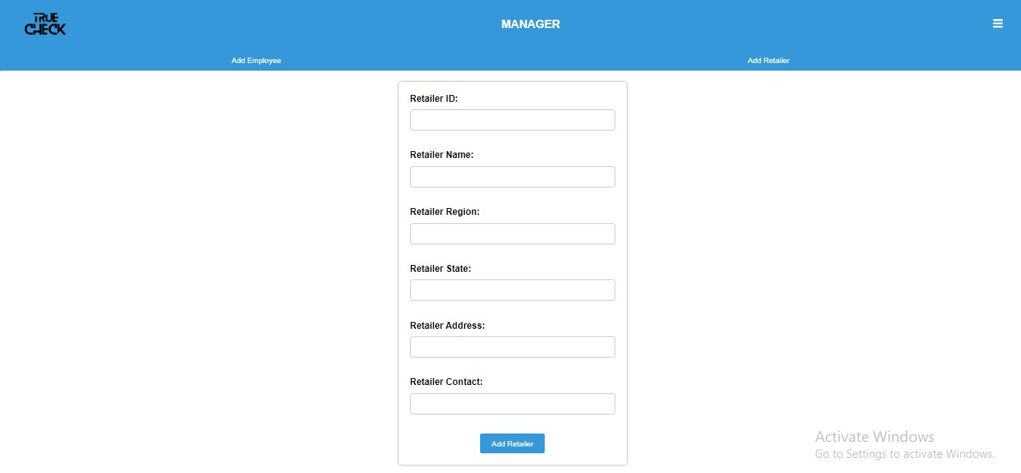

Fig. 7.4.2 Manager Panel 2 : Add Retailer

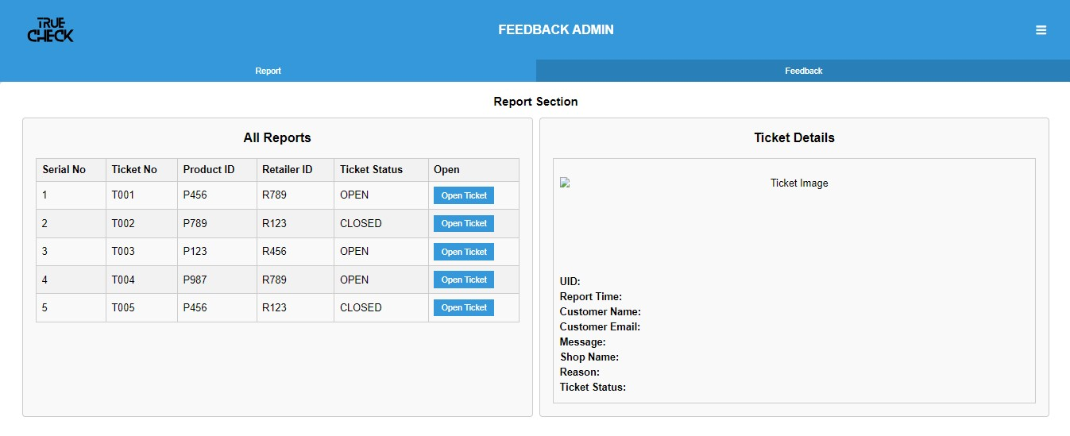

Fig. 7.5.1 Feedback Admin Panel 1: Report Section (All Tickets)

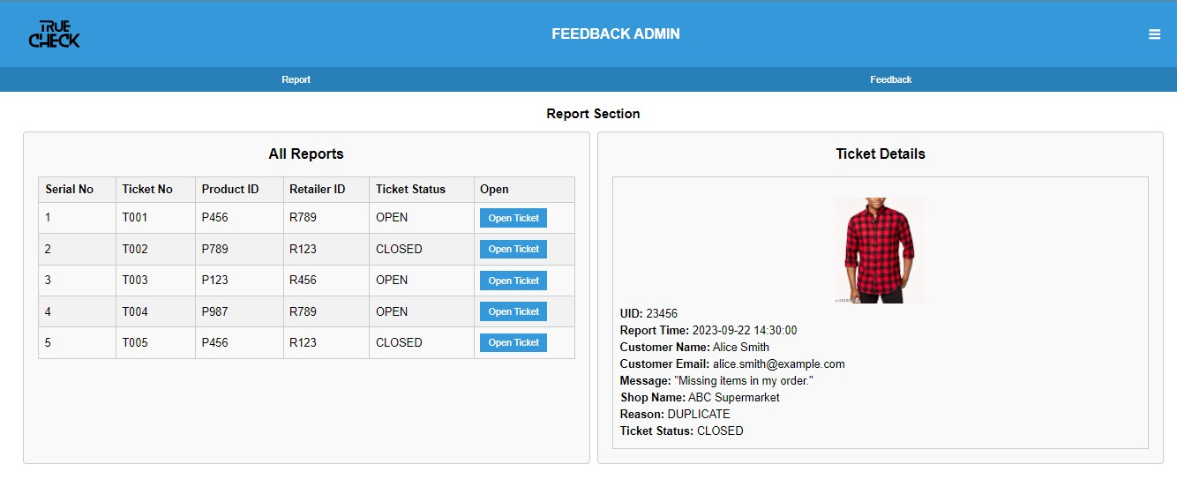

Fig. 7.5.2 Feedback Admin Panel 1: Report Section (Ticket Opened)

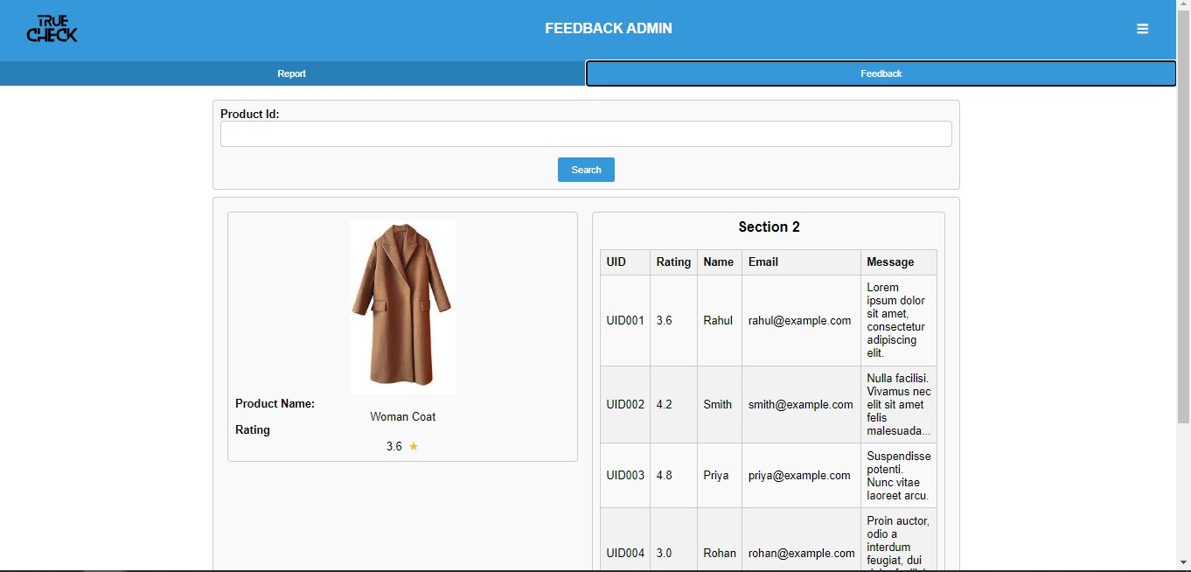

Fig. 7.5.3 Feedback Admin Panel 2: Feedback Section

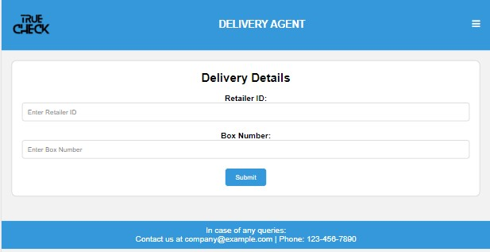

Fig. 7.4 Delivery Agent Dashboard



Fig. 7.5 Error Page



Fig. 7.6 Admin Error Page

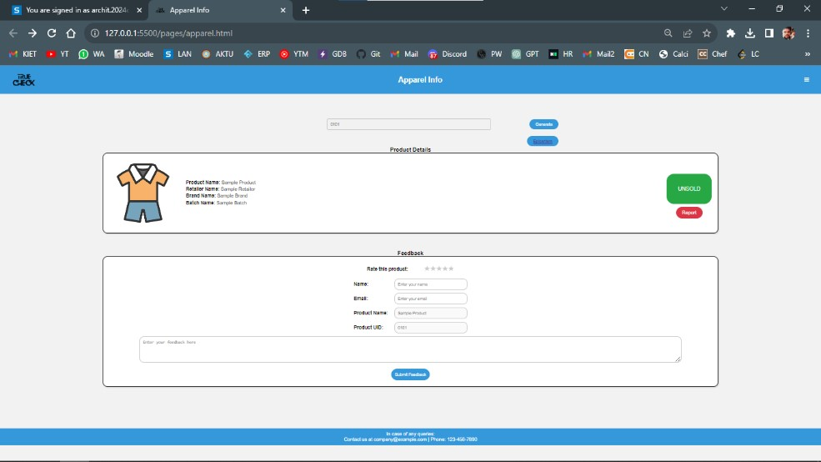

Fig. 7.7 Landing Page after QR Code is redirected

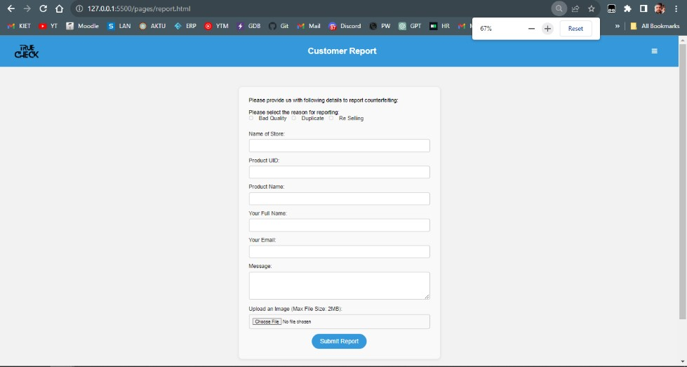

Fig. 7.8 Report Form

#### 7.2 DESCRIPTION OF VARIOUS MODULES WITH SNAPSHOTS

Here's how the Counterfeit Detection System works:

1. **QR Code Scanning**: As consumers prepare to make a purchase, they encounter a crucial checkpoint—the QR code affixed to the product. With a quick scan using their mobile devices, they initiate the process.

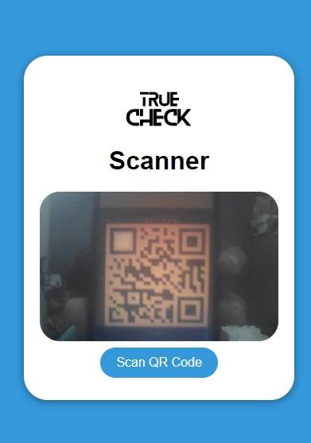

Fig. 7.9 Scanning the QR

1. **Validation and Product Details:** The system springs into action, rigorously validating the QR code's authenticity. If the QR code checks out as genuine, users are seamlessly redirected to the official website of the brand, where a wealth of essential product details awaits. These details include a stamp of authenticity from the brand, the original price of the product, its current sold status, and insights into its supply chain journey.



Fig. 7.10 Redirected Page after QR is scanned



Fig. 7.11 Report Page

1. **Informed Decision-Making**: Armed with this valuable information, consumers are empowered to make informed decisions about their purchase. If the product is confirmed as new and unsold, they can proceed with confidence, knowing they are acquiring an authentic item. On the other hand, if the QR code raises any doubts or the product has been resold, the system triggers an alert, both to the user and the concerned brand. This proactive approach serves as a powerful deterrent to counterfeit activity.

#### 7.3 KEY FINDINGS OF THE PROJECT

Upon comprehensive testing and evaluation, the following key findings emerged, providing valuable insights into the performance and functionality of the Counterfeit Detection System:

* **Effectiveness of QR Code Authentication:** The QR code authentication mechanism proved highly effective in verifying the authenticity of clothing products. Through rigorous validation processes, the system accurately determined whether a product was genuine or counterfeit, empowering users to make informed purchasing decisions.
* **User-Friendly Interface:** Positive feedback was received regarding the system's user interface, lauding its intuitiveness and ease of use. Users found it straightforward to scan QR codes, access product details, and receive alerts about counterfeit products. The intuitive design contributed to a seamless user experience and increased user engagement.
* **Scalability and Performance:** Performance testing confirmed the system's scalability and robustness in handling concurrent scanning requests and user interactions. The system maintained optimal performance levels, with minimal response times and resource utilization under varying loads, ensuring a seamless user experience.
* **Potential for Further Enhancements:** While the current version of the system is functional, there is scope for further enhancements and feature additions. Future iterations could explore integrating machine learning algorithms for enhanced product authentication, expanding coverage to additional industries, and improving real-time monitoring capabilities.

**7.4 BACK-END REPRESENTATION (DATABASE TO BE USED )**

Table 7.1 Admin Table



Table 7.2 Brand Product Retailer Table

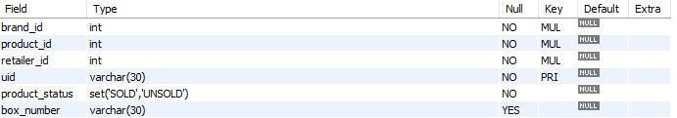

Table 7.3 Product Details Table

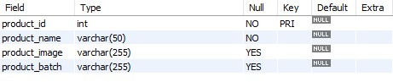

Table 7.4 Retailer Table

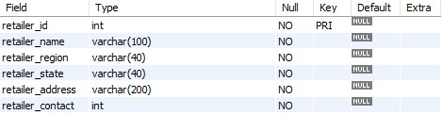

Table 7.5 Feedback Table

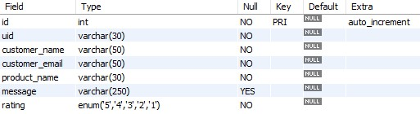

Table 7.6 Report Table

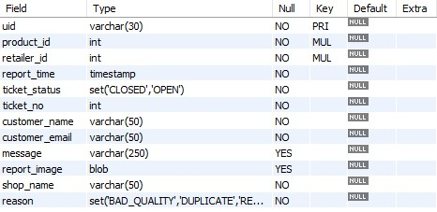

**CHAPTER 8**

**CONCLUSION AND FUTURE SCOPE**

### 8.1 CONCLUSION

The proposed Counterfeit Detection System, centred around QR code technology, serves as a safeguard against counterfeit products. It empowers consumers to make informed purchasing decisions by providing real-time authentication and product information. By leveraging the strength of QR codes, consumers can easily verify the authenticity of clothing products, thereby ensuring their safety and protecting their trust in legitimate brands.

### 8.2 FUTURE SCOPE

The future scope of the counterfeit detection system includes integrating machine learning to improve the accuracy and efficiency of product authentication, expanding to cover various industries, implementing real-time monitoring and tracking, fostering partnerships with government agencies and industry associations, and developing user-friendly mobile applications for instant authentication. These advancements will enhance the system's effectiveness in combating counterfeiting and protecting consumers and businesses.

## REFERENCES

1. [Tiwari, S. (2016). "An introduction to QR code technology." In 2016 International Conference on Information Technology (ICIT). Department of Technical Education, SITS Educators Society, Jabalpur, Madhya Pradesh, India.](https://ieeexplore.ieee.org/document/7966807)

1. [Patel, A. K., & Singh, A. (2018). "A STUDY ON COUNTERFEIT BRANDS, CONSUMER ATTITUDE AND INITIATIVES TO STOP COUNTERFEITING IN INDIA." AD VALOREM - Journal of Law, 5(II), April - June 2018, ISSN: 2348-5485.](https://www.researchgate.net/publication/356085681_A_STUDY_ON_COUNTERFEIT_BRANDS_CONSUMER_ATTITUDE_AND_INITIATIVES_TO_STOP_COUNTERFEITING_IN_INDIA)

1. [Picard, J., Landry, P., & Bolay, M. (2021). "Counterfeit detection with QR codes." In Proceedings of the 21st ACM Symposium on Document Engineering.](https://dl.acm.org/doi/10.1145/3469096.3474924)

1. [Pio, L., Cavaliere, L. P. L., Mangalasserri, K., Venkateswaran, P. S., Byloppilly, R., Effendy, F., More, A., Rajest, S., & Rajan, R. (2021). "THE IMPACT OF BRAND COUNTERFEITING ON CONSUMER BEHAVIOR IN THE FASHION SECTOR."](https://www.researchgate.net/publication/355041587_THE_IMPACT_OF_BRAND_COUNTERFEITING_ON_CONSUMER_BEHAVIOR_IN_THE_FASHION_SECTOR)

1. [Staake, T., Thiesse, F., & Fleisch, E. (2004). "Extending the EPC Network – The Potential of RFID in AntiCounterfeiting." Report No. 27, October 20, 2004. Authors: Thorsten Staake, Frederic Thiesse, Elgar Fleisch.](https://www.researchgate.net/publication/236647561_Extending_the_EPC_network_-_The_potential_of_RFID_in_anti-counterfeiting)

1. [International Chamber of Commerce. (2016). "The Economic Impacts of Counterfeiting and Piracy."](https://iccwbo.org/wp-content/uploads/sites/3/2017/02/ICC-BASCAP-Frontier-report-2016-Executive-Summary.pdf)

1. [Daoud, E., Vu, D., Nguyen, H., & Gaedke, M. (2020). "IMPROVING FAKE PRODUCT DETECTION USING AI-BASED TECHNOLOGY.”](https://www.researchgate.net/publication/339983307_IMPROVING_FAKE_PRODUCT_DETECTION_USING_AI-_BASED_TECHNOLOGY)

1. [Yoon, B., Lee, J., Park, I. S., Jeon, S., Lee, J., & Kim, J. M. (2013). "Recent functional material based approaches to prevent and detect counterfeiting."](https://pubs.rsc.org/en/content/articlelanding/2013/tc/c3tc00818e)

1. [Wasnik, K., Sondawle, I., Wani, R., & Pulgam, N. (2022). "Detection of Counterfeit Product using Blockchain."](https://www.itm-conferences.org/articles/itmconf/pdf/2022/04/itmconf_icacc2022_03015.pdf)

1. [Guin, U., DiMase, D., & Tehranipoor, M. (2014). "Counterfeit Integrated Circuits:](https://link.springer.com/article/10.1007/s10836-013-5430-8) [Detection, Avoidance, and the Challenges Ahead."](https://link.springer.com/article/10.1007/s10836-013-5430-8)

1. [Horn, C., Blankenburg, M., Fechteler, M., & Kruger, J. (2013). "Product Piracy Prevention: Product Counterfeit Detection Without Security Labels."](https://go.gale.com/ps/i.do?id=GALE%7CA353645958&sid=googleScholar&v=2.1&it=r&linkaccess=abs&issn=23050012&p=AONE&sw=w&userGroupName=anon%7E68e5e571&aty=open-web-entry)

1. [Choi, S. H., & Poon, C. H. (2007). "An RFID-based Anti-counterfeiting System."-](https://www.iaeng.org/publication/WCE2007/WCE2007_pp1082-1087.pdf)
2. https://github.com/KIET-Github/CS-2024-A/tree/main/PCS-1-Archit

**PAPER PUBLICATION**

**Research Paper Communicated**

Fig. 7.1 Submission Status